**Steps for PEM rotation**

1. login to aws console & select EC2 instance dashboard
2. You can see **Key pair** name under the Network & Security tab

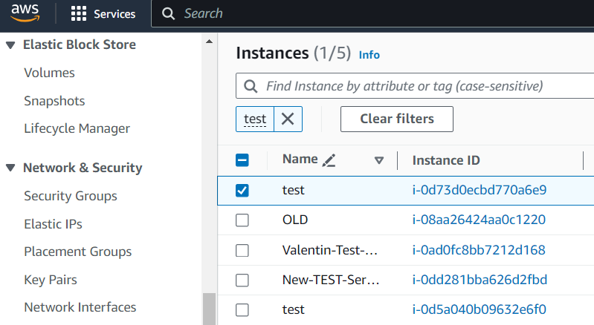

1. create a new key pair

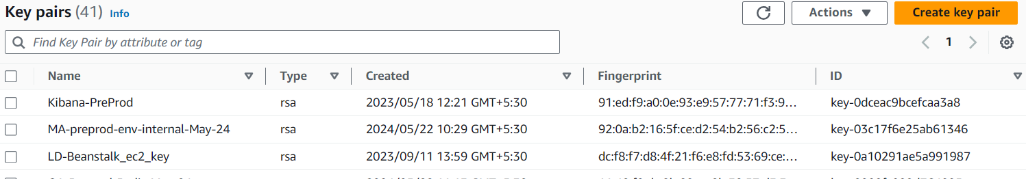

1. Thinks to note here our server name in test so for the change we have to give test-may24 this denotes our month and year of changing pem key and should be in .pem format and give create

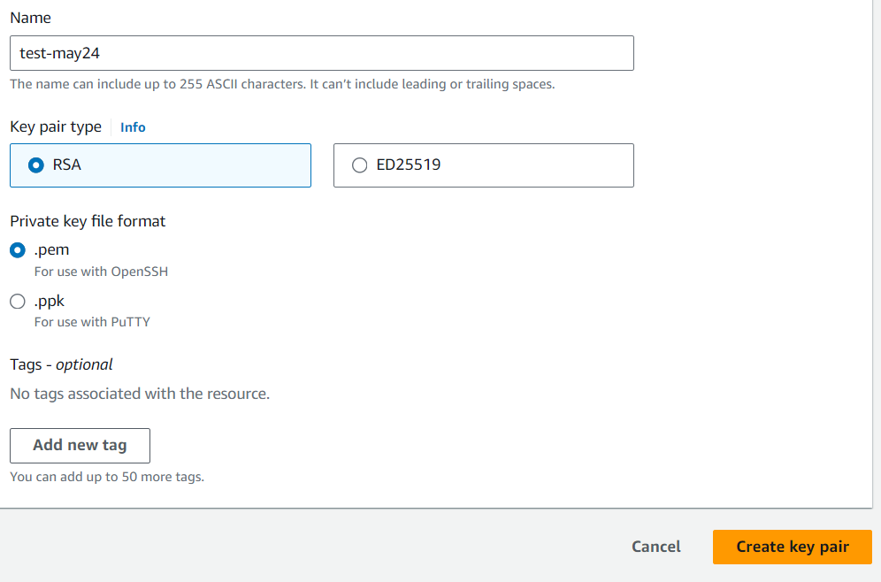

1. Your test-may24 pem file will be downloaded in your download location ,We have to change that format of our key open your cmd prompt and run as admin.

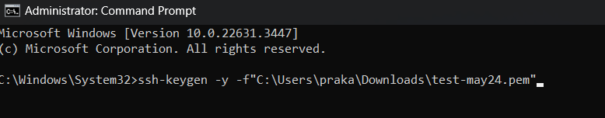

1. and enter the cmd **ssh-keygen -y -f”path of the key stored”.**

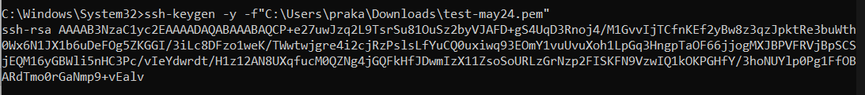

1. You will get a key , copy that and key in note pad

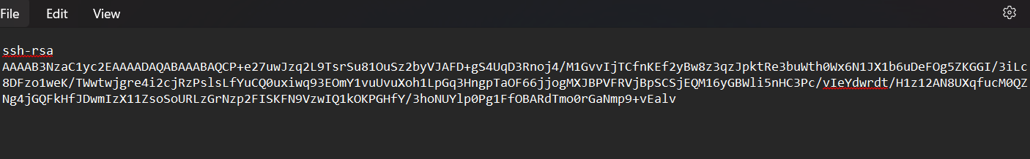

8.login to aws console & select EC2 instance dashboard

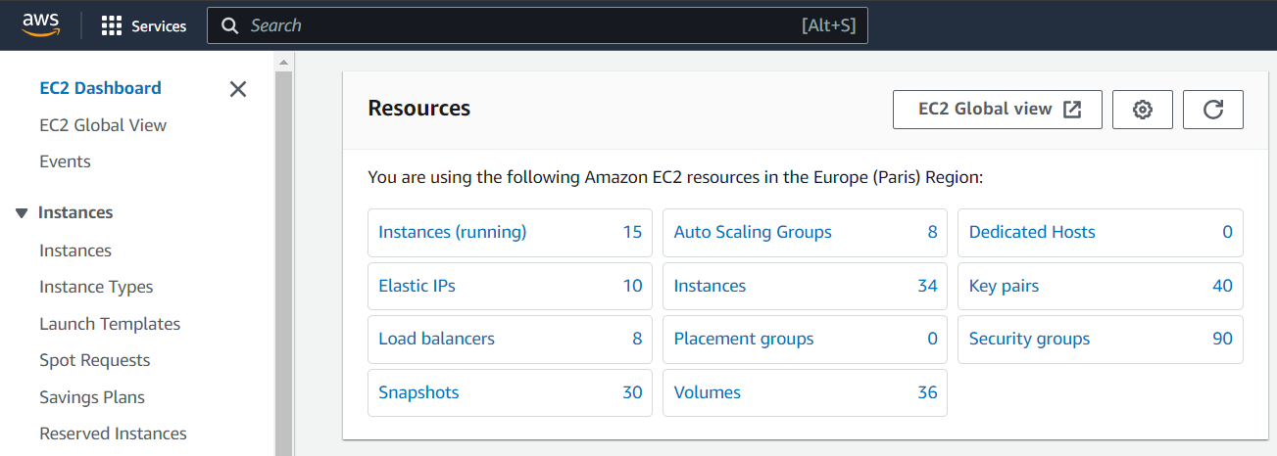

9.select the server you want to change the pem key

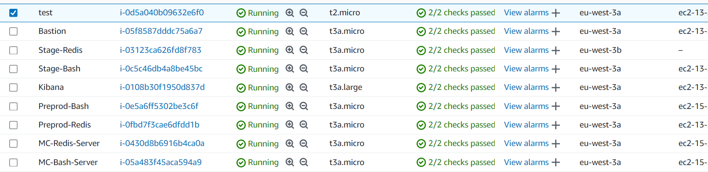

10.And select connect

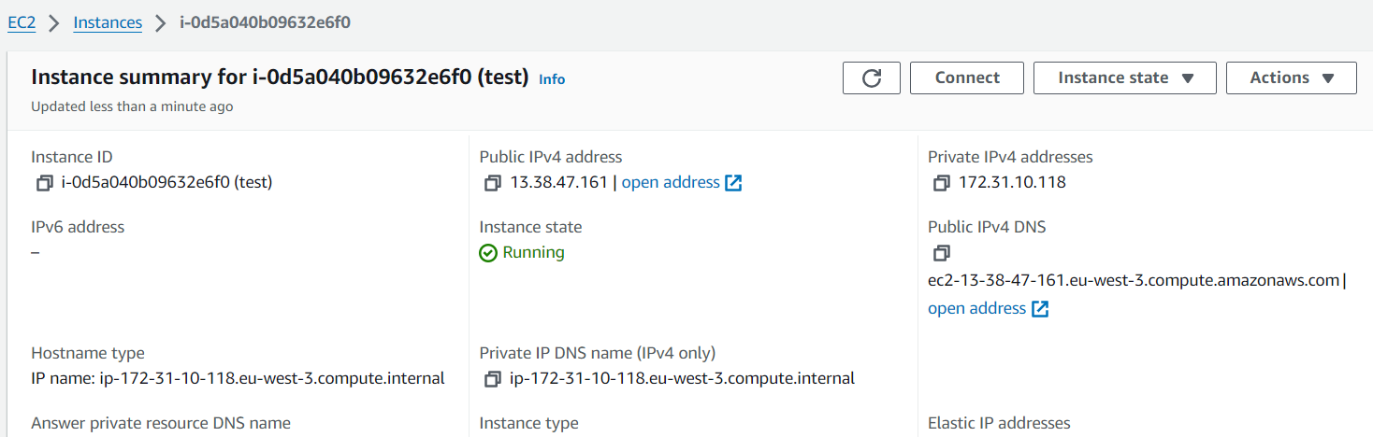

1. And connect using EC2 connect or session manager

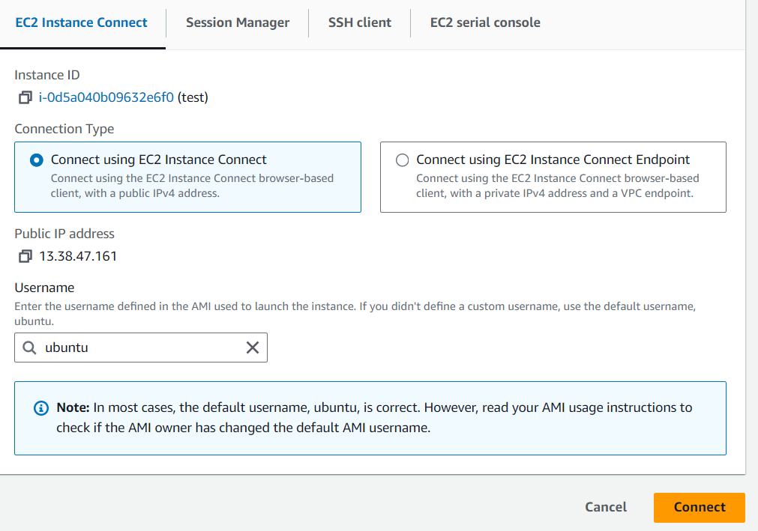

1. After connecting give cmd sudo su to switch to root user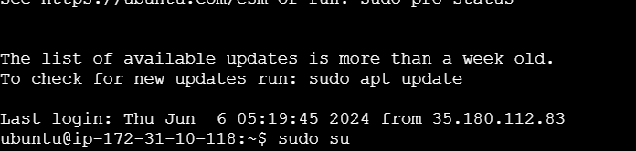

13.Then we have to go to library file of key stored for that we have to give nano /home/ubuntu/.ssh/authorized_keys



1. After giving enter you can see old key there give # in front of that old key . and paste the new key that we had in notepad

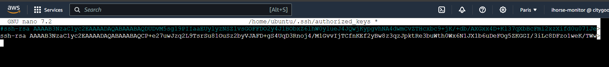

1. Give the name after pasting the new key with space **test-may24** for our reference

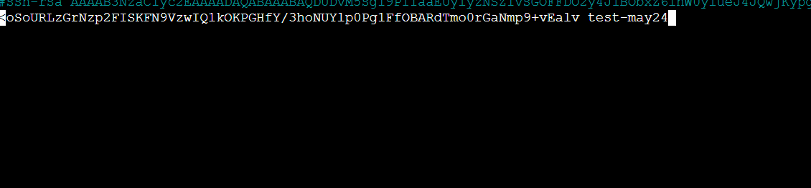

1. Then give **ctrl + S** to save then **ctrl + X** to exit
2. We have to check that our changed key is working so have to change pem key to ppk so using putty gen we will generate our ppk key

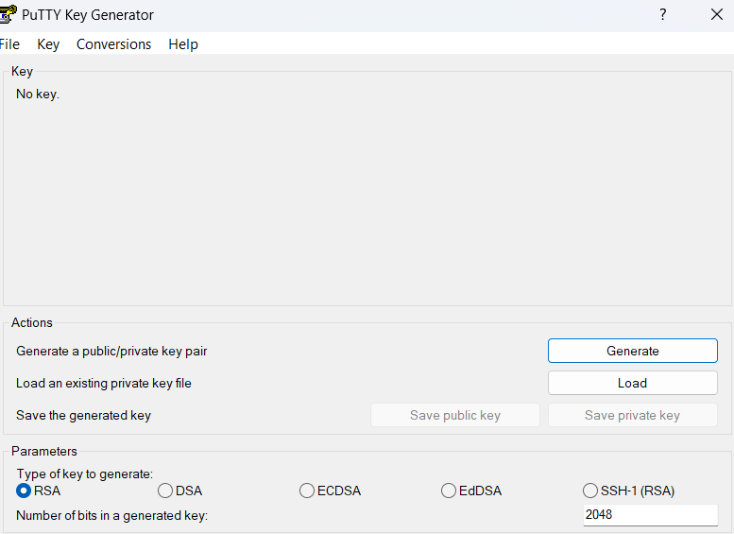

1. load the pem key in downloads

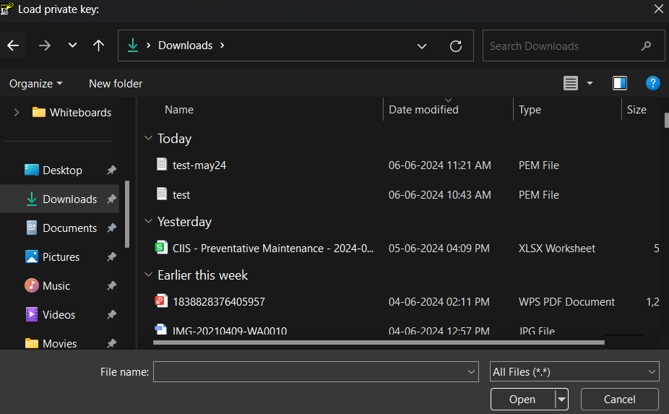

1. You will get this , click OK

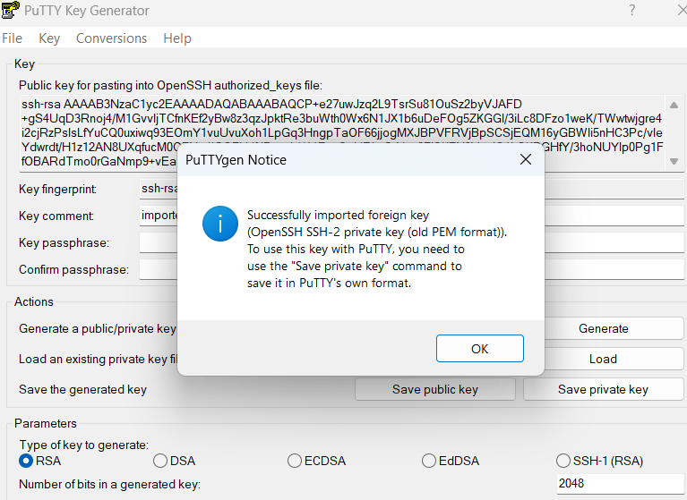

1. Then save the private key and give name has test-may24 and Save

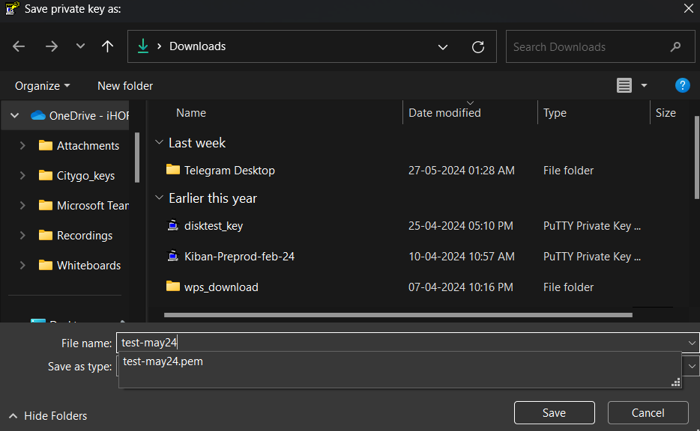

21.Then open Putty application, copy the ip address of test server

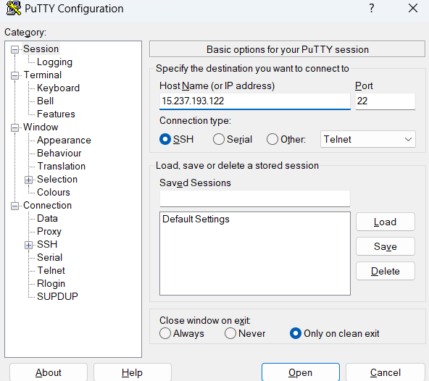

22.And select SSH->Auth->credential -> browse 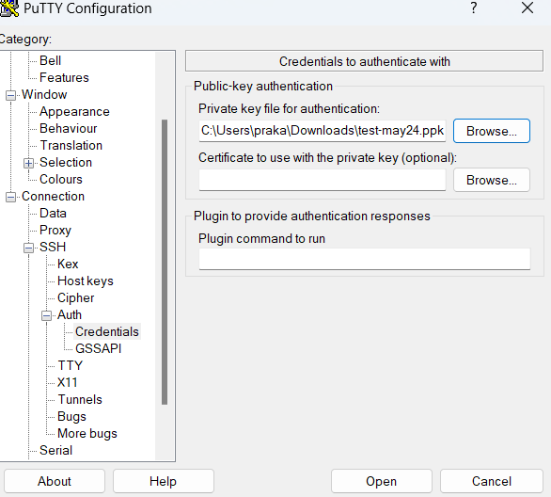

1. And select the ppk file

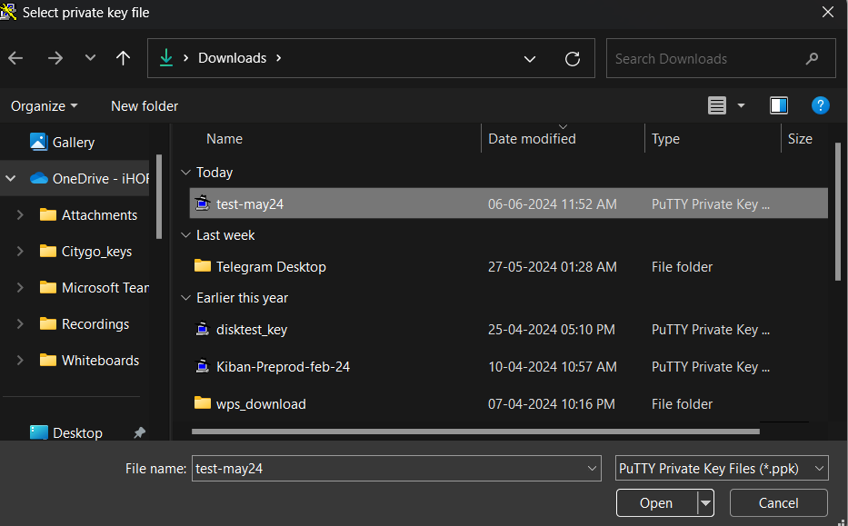

1. And login has ubuntu , you are done.

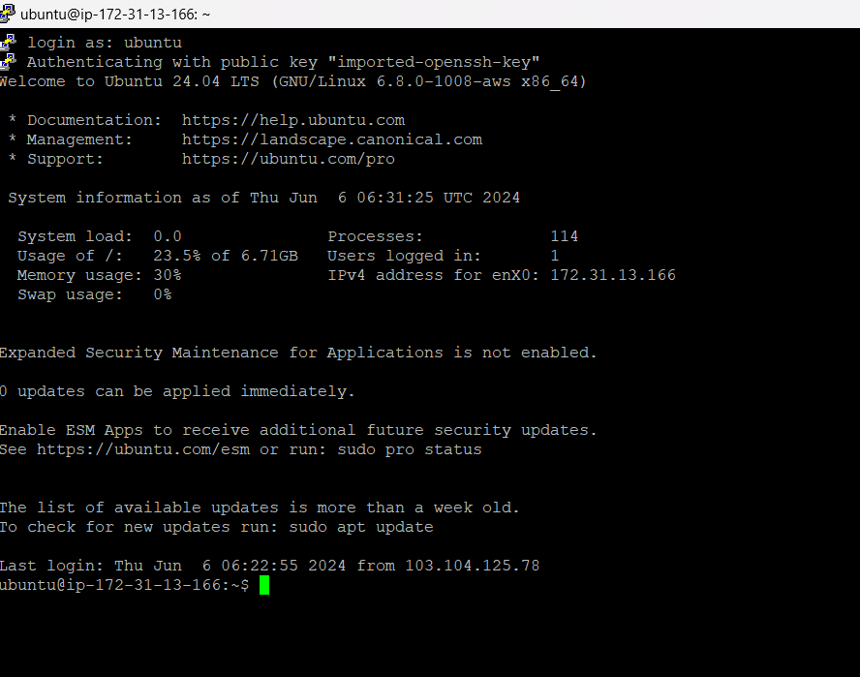

1. After connected successfully exit the server
2. we have to save the key in our aws secret manager

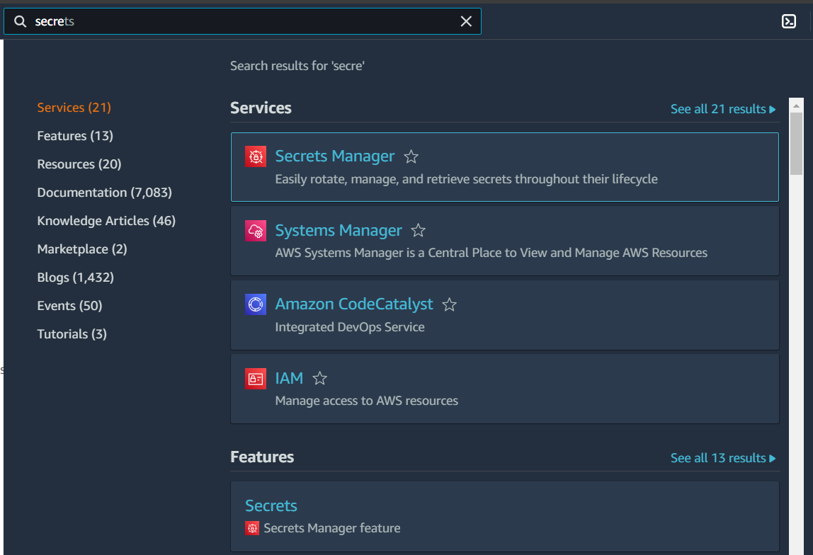

1. go to secret manager and click on store and new secret key

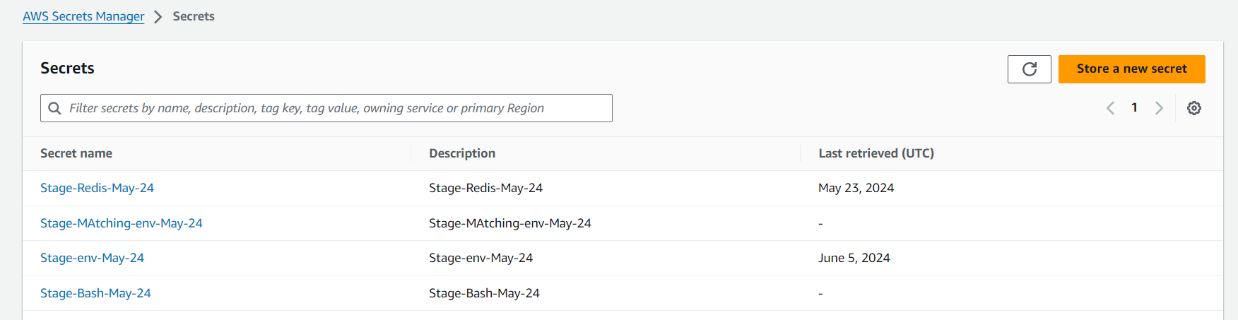

1. click on other type and add plain text from the test pem file , for that open test pem file in notepad and copy .

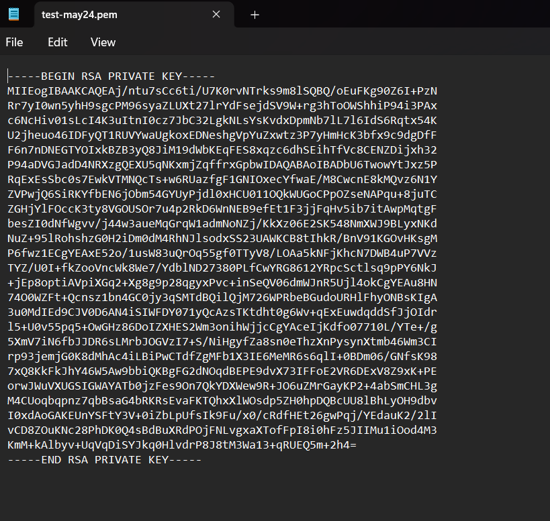

.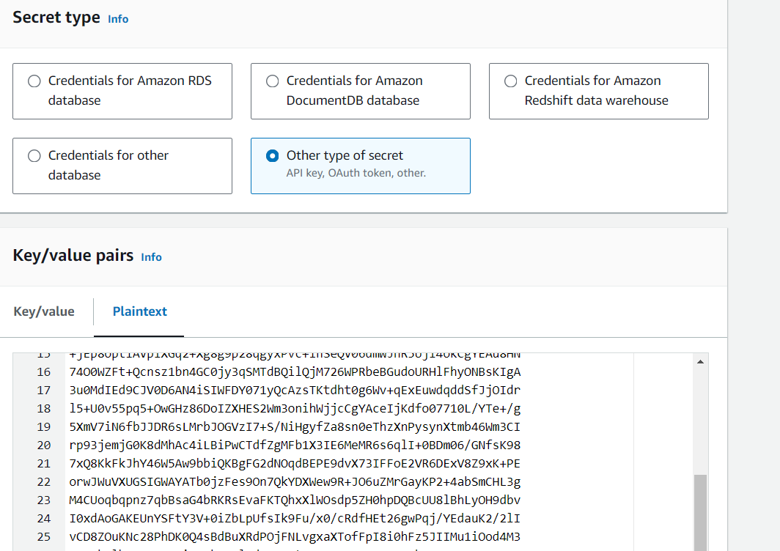

1. And then give secret and description has below and give

next->next->store.

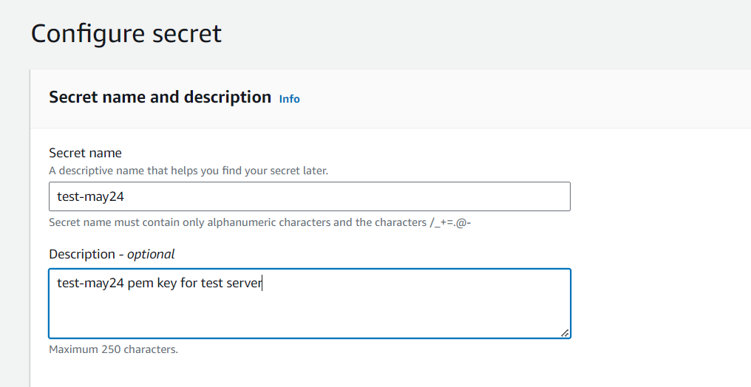

30.Done, 